EXPERIMENT – 14
ANNOTATED PARSE TREE CONSTRUCTION AND EVALUATION
Aim
To write a C program that constructs an annotated parse tree for the grammar E → E + T, E → T, T → num and evaluates the given arithmetic expression.
Grammar
E → E + T
E → T
T → num
Pseudo Code
1. Start the program.
2. Read the arithmetic expression from the user.
3. Create a pointer to traverse the expression.
4. In parseT(), skip spaces, read the number, and create a T node with a num child.
5. In parseE(), first parse a T node.
6. While the next non-space character is '+':
a. Move past the '+' operator.
b. Parse the next T node.
c. Add the values of the left and right nodes.
d. Create a new E node containing the result and the two child nodes.
7. Display the annotated parse tree recursively.
8. Print the final evaluated value stored at the root node.
9. Stop.
C Program
#include <stdio.h>
#include <stdlib.h>
#include <ctype.h>
#include <string.h>
typedef struct Node {
char name[10];
int val;
struct Node *left, *right;
} Node;
Node* createNode(const char *name, int val,
Node *left, Node *right) {
Node *n = (Node*)malloc(sizeof(Node));
if (n == NULL) {
printf("Memory allocation failed.\n");
exit(1);
}
strcpy(n->name, name);
n->val = val;
n->left = left;
n->right = right;
return n;
}
void skipSpaces(char **s) {
while (isspace((unsigned char)**s))
(*s)++;
}
/* Parse T -> num */
Node* parseT(char **s) {
int num = 0;
skipSpaces(s);
if (!isdigit((unsigned char)**s)) {
printf("Invalid expression: number expected.\n");
exit(1);
}
while (isdigit((unsigned char)**s)) {
num = num * 10 + (**s - '0');
(*s)++;
}
return createNode("T", num,
createNode("num", num, NULL, NULL),
NULL);
}
/* Parse E -> E + T | T */
Node* parseE(char **s) {
Node *left = parseT(s);
while (1) {
skipSpaces(s);
if (**s != '+')
break;
(*s)++;
Node *right = parseT(s);
int result = left->val + right->val;
left = createNode("E", result, left, right);
}
return left;
}
/* Display the annotated parse tree */
void display(Node *root, int level) {
if (root == NULL)
return;
for (int i = 0; i < level; i++)
printf(" ");
printf("%s = %d\n", root->name, root->val);
display(root->left, level + 1);
display(root->right, level + 1);
}
int main(void) {
char expression[100];
char *s;
Node *root;
printf("Enter arithmetic expression: ");
if (fgets(expression, sizeof(expression), stdin) == NULL)
return 1;
s = expression;
root = parseE(&s);
skipSpaces(&s);
if (*s != '\0' && *s != '\n') {
printf("Invalid expression: unexpected character '%c'.\n", *s);
return 1;
}
printf("\nAnnotated Parse Tree:\n");
display(root, 0);
printf("\nFinal Evaluated Value = %d\n", root->val);
return 0;
}
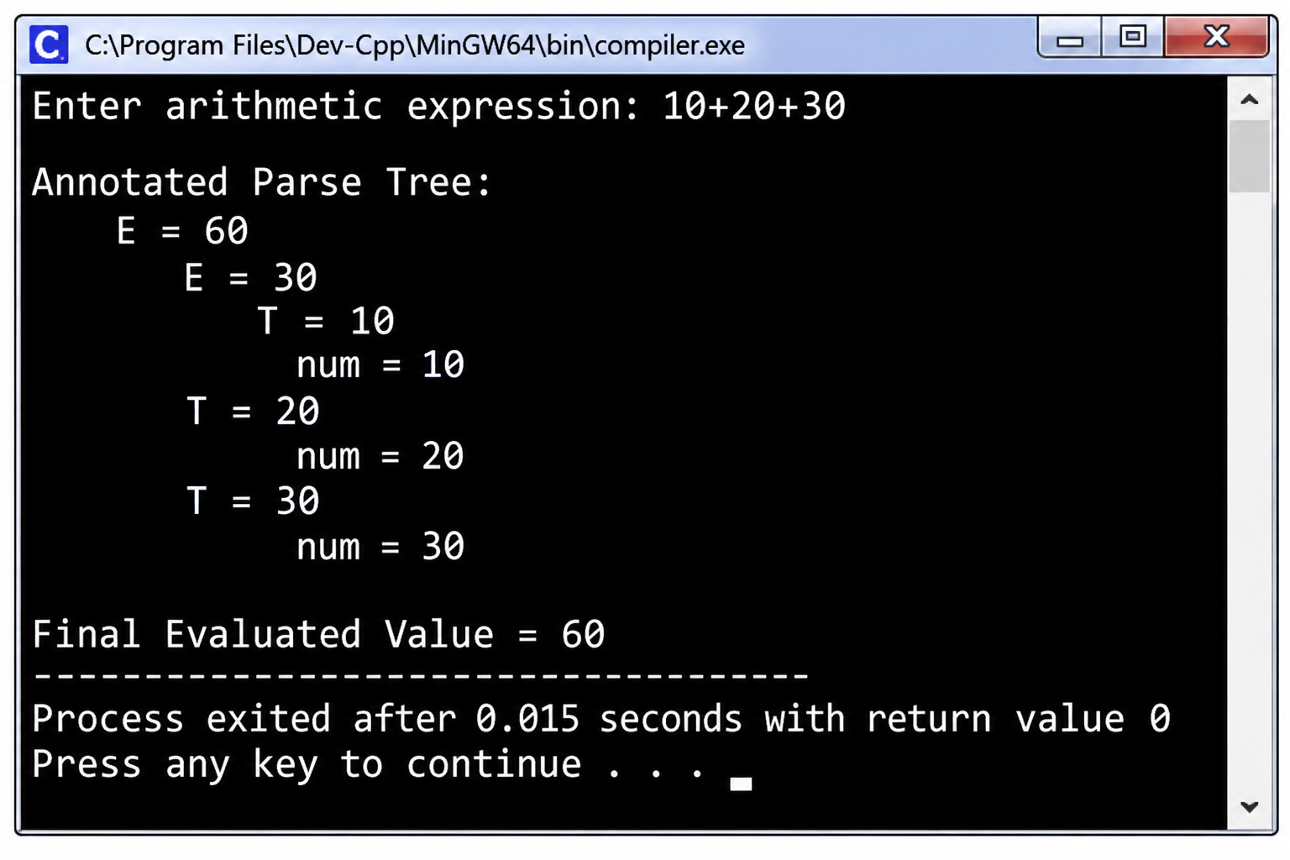
Result
Thus, the C program successfully constructs the annotated parse tree and evaluates the arithmetic expression. For the input 10+20+30, the final value is 60.

